Beyond the Basics of
Creating Presentations

Microsoft PowerPoint 2010

Instructor: Ima Instructor

Presented and co-sponsored by:



11 East Superior Street, Suite 210


Duluth, MN 55802
218-726-7298 (main)
888-387-4594 (toll free)
www.umdced.com
ced@umdced.com

Copyright© 2012 University of Minnesota Duluth
Center for Economic Development.
All Rights Reserved.
Reproduction of this printed material in whole or in part without permission is prohibited.
Microsoft and Access are either registered trademarks or trademarks of Microsoft Corporation in the United States and/or other countries.
The University of Minnesota Duluth is an equal opportunity employer and educator.
The Mission of the University of Minnesota Duluth Center for Economic Development is to assist entrepreneurs and businesses to grow and succeed.

The Minnesota Small Business Development Center program is funded in part through a Cooperative Agreement with the U.S. Small Business Administration, Minnesota Department of Employment and Economic Development and regional support partners. All opinions, conclusions or recommendations expressed are those of the author(s) and do not necessarily reflect the program sponsors. Programs are open to the public on a nondiscriminatory basis. Reasonable accommodations for persons with disabilities will be made if requested at least two weeks in advance.

U: 20121009-195300

Workshop Outline for Beyond the Basics of Creating Presentations
Microsoft PowerPoint 2010

Objectives 4
Slide Master and Custom Theme 4
Organization Charts 5
Auto Shapes-Creating a Flow Chart 8
Creating Tables 8
Linking Objects 8
Inserting Existing Slides from Another Presentation 9
Slide Timings 9
Custom Animations 9
Action Buttons 9
Import and Modify an Existing Word outline 10
Working with Drawing Section of the Ribbon 10
Create a Photo Album Presentation in PowerPoint 11

Beyond the Basics of Creating Presentations

Go beyond the basics to creating customized professional presentations. Learn how to design templates, create organization and flow charts and much more for a positive impression and appearance. This is a hands-on workshop.

PowerPoint allows you to easily blend Microsoft Word outlines, Microsoft Excel worksheets, and Microsoft Clip Organizer illustrations into your own original PowerPoint text and graphics.

Objectives

- Understanding Master Slides
- Create a design Template
- Slide Timings
- Custom Animation
- Action Buttons

Start the PowerPoint program.

The best way to start Powerpoint in Windows 7 is to go to the Windows Button and start typing Word in the “Search for Programs and Files” search bar. It should be the first program on the top of the start menu.

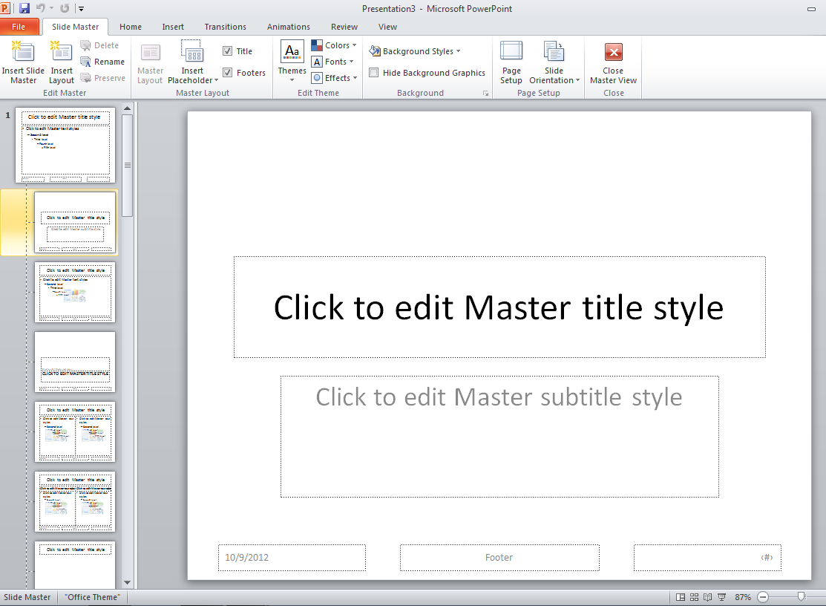
Slide Master and Custom Theme

The Slide Master controls the format of slides. It contains formatting placeholders for the title and text as well as background items. If you make formatting changes in the slide master, the change applies to all of the slides in the presentation.

    - On the Ribbon, Select the View Tab >Master Views>Slide Master, or hold down the Shift key and click on the Slide View or Normal View button.
    - Click the area of the slide to be changed.
    - Use the Ribbon to make the desired changes.
- Master Title Area - controls the font, size, color, style and alignment of the text in the title area.
- Master Object Area - controls the font, size color, style and alignment, line spacing, bullet style and paragraph indents of the slide text.
- You can also add background items such as logos, borders, lines, date, time, page numbers and the presentation name within the slide master.



Organization Charts

- Click the New Slide Icon on the Ribbon.
- Select the SmartArt Graphic in the center of the new slide.
- Select Heirarchy
- Double-click the organization chart placeholder.

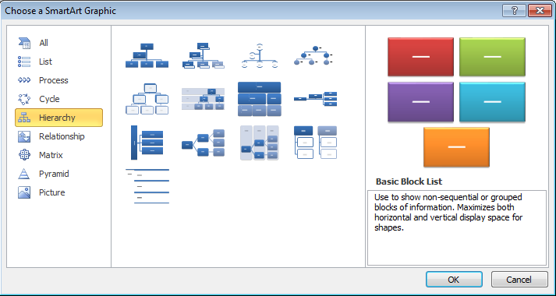

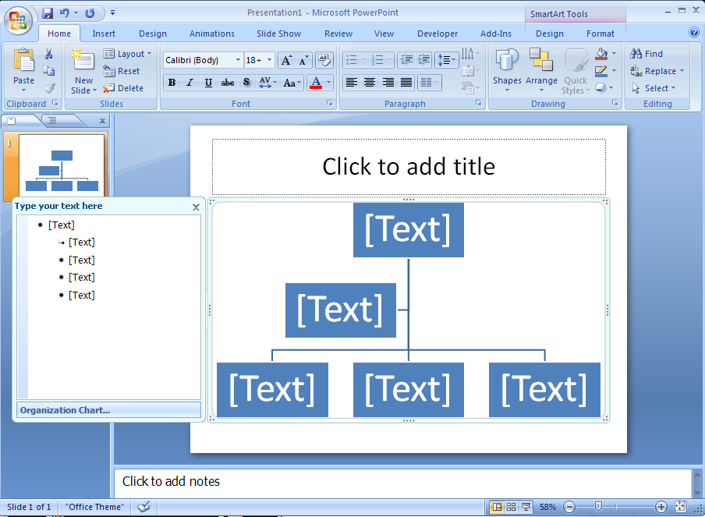
Entering Text in a Box
- Click on the box in which you want to add information
- Type the desired text
- Press Enter to move to the next line.
- Click outside of the box

Adding Boxes to an Organization Chart
- On the SmartArt Tools, Design Tab, click the Add Shape drop-down button to select what type of object to add.
- Make sure you are on the box to add to when selecting the shape.

Deleting a Box
- Select the box to be deleted.
- Press the Delete key on the keyboard.

Moving a Box
- In the Organization Chart hierarchy, select the position you want to move
- Right-click and select Promote or Demote. In the sample case, select promote.

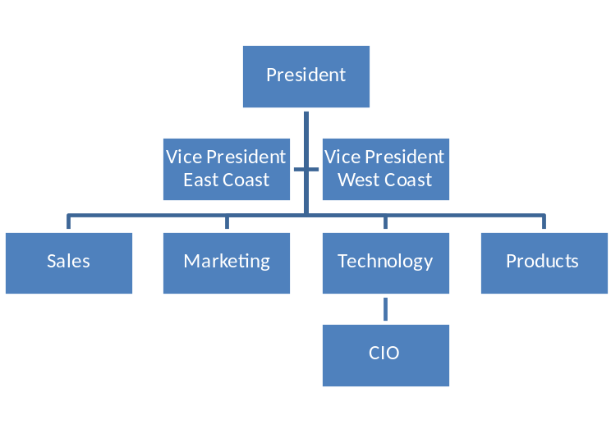
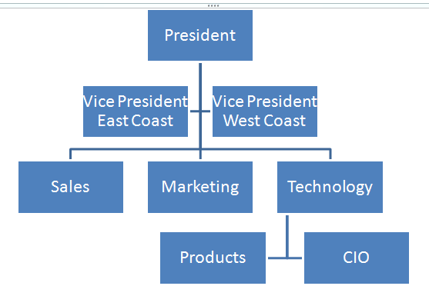

To change the Design look of the Organizational Chart Go to SmartArt Tools, Design, SmartArt Styles. As the cursor goes over each of the styles, the current Org. Chart changes its look. The type of Org. Chart (layout), can also be changed. Experiment with each of these Galleries to get the desired look.

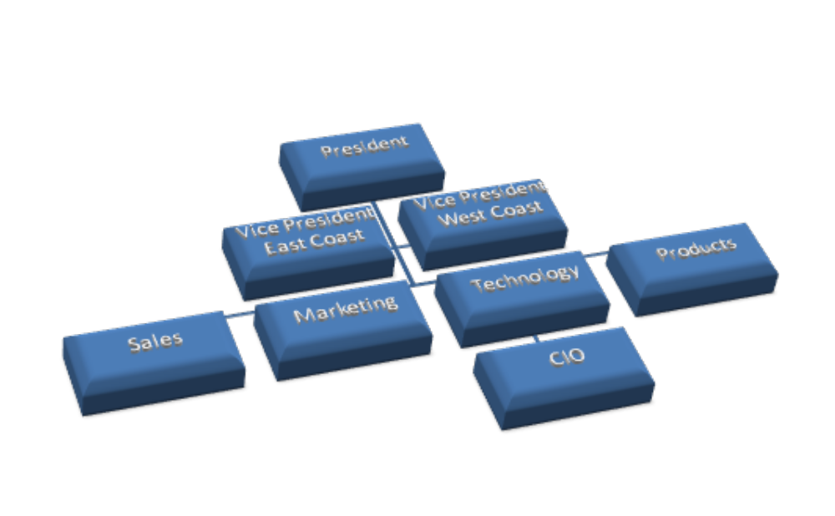

Exiting MS Organization Chart Click off the chart.

Auto Shapes-Creating a Flow Chart

- Create a new slide on the Home tab of the Ribbon.
- In the Drawing section, many of the AutoShapes are visible. If the one that is required is not visible, select the dropdown arrow next to all of the shapes to see the entire gallery.
- Click on the shape and then click within the slide to place the shape.
- To add text, right-click the shape, select Edit Text, then type the desired text with the shape.
- Repeat until all shapes are drawn.
- To create the connecting lines select the dropdown arrow next to all of the shapes to see the entire gallery. Click on the requested Line.
- The lines are now selected in the Drawing Selector Box.
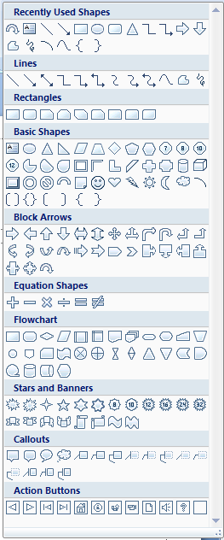
- Click on the first box to have a line connected, then click the box it is to be connected to. Repeat for all connecting lines.
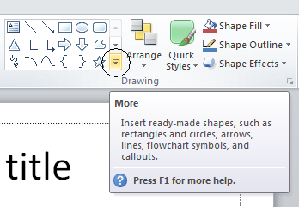

Creating Tables

Creating Tables in PowerPoint (Normal or Slide View)
Create a new slide and choose the Table icon.
Determine number of column and rows necessary
Type in text
Adjust column widths or row heights using the double-arrow indicator.

Linking Objects

Linking allows you to import another object (i.e. an excel spreadsheet) into your presentation so that when changes are made to the object, the change automatically takes place within the object linked into your presentation.

- From the Ribbon select the Insert Tab, then Object.
- Select Create from file.
- Browse to select the file, or type the path to the file
- Click the Link check box.
- Click OK.

Inserting Existing Slides from Another Presentation

- Open the presentation to which you want to add a slide.
- The new slide will be added after the slide you are on.
- Select the drop-down from the New Slide button.
- Select Reuse Slides… at bottom. The Reuse Slides task pane comes up.
- Type the file location path or click the Browse Button (and Browse File…) to select the presentation where the slide exists.
- Click the desired slide to select it.
- Click Insert to add it to the presentation.
- Note: To retain formatting, click Keep Source Formatting.

Slide Timings
Automatic timings allow the slide show to automatically move to the next slide at specified intervals.

- In Slide Sorter view, click the slide(s) to have a timing applied.
- On the Ribbon, go to the Animations tab.
- In the Slide Transition dialog box, select Automatically After.
- Enter the number of seconds for the slide to display before the presentation moves to the next slide.

Custom Animations

- In Normal or Slide View, select Animations from the tabs.
- Select the items to be animated.
- For each item to be animated on the slide, select the desired options within Transition to This Slide.
- Click OK.

Action Buttons - Action buttons, which create hyperlinks, can be added to your presentation to make it interactive.

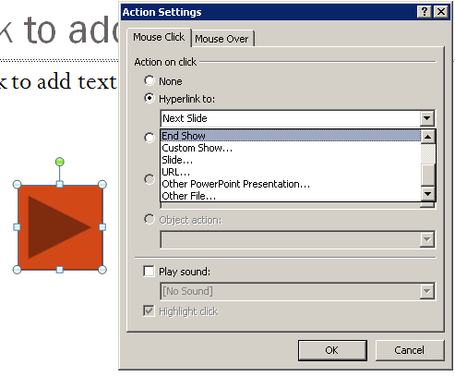
- From the Home tab on the Ribbon, select Shapes, Action Buttons, then the desired Action button.
- Click the location on the slide where the button should be.
- Select what it will hyperlink to (i.e. the next slide, an Excel file, etc.).
- Click OK.

Import and Modify an Existing Word outline - The outline will be inserted into the active presentation, so if you have just started, you can use the whole outline as your presentation. Each first-level heading will become a new slide. When you insert a Word outline, the complete document appears as part of your presentation. (Covered in Customize Presentation)

Type this into Word if not already done:

Fixing a computer
- Ground yourself
  - Touch case
  - Drink heavily
    - Water
    - Scotch
- Remove case
  - Remove screws with Phillips screwdriver
  - May be thumb screws
- Remove bad part
  - Can’t throw in garbage anymore
  - Find acceptable recycling
- Put in new part
- Load Driver(s)

Save this file. Start a new presentation and open the file in Powerpoint.

Working with Drawing Section of the Ribbon

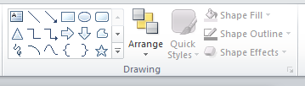

- Creating shapes (Normal or Slide View)
Use Slide Layout and choose a Title only layout: Insert>New Slide
From the Home tab of the ribbon, create shapes, shapes, text

- Arrange
Select object you want to reorder
From the Home tab of the ribbon, choose Arrange and change order

- Nudging
Select object you want to nudge
Use arrow keys to move

- Grouping
Select all objects you want to group (Shift click or lasso)
  - From Drawing Tools / Format Tab on the Ribbon, choose Group

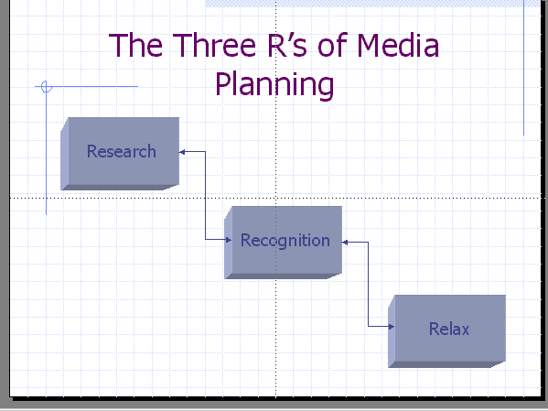

- Time saving tip:
- When editing slides, use the Pasteboard (blank area surrounding the slide) to place graphics, drawing items, blocks of text, etc., and you work on the slide.

Create a Photo Album Presentation in PowerPoint

- On the File Button, select new and then pick the Sample Templates.
- Select either the Classic Photo Album or Contemporary Photo Album.
- This photo album contains sample pages to get you started. To add your own pages, click the Home tab, then click the New Slide gallery.
- Repeat Step 3 for as many pictures as you want to add to your photo album. Or to capture them all at once, hold down the CTRL key, click each picture file you need, and then click Insert.
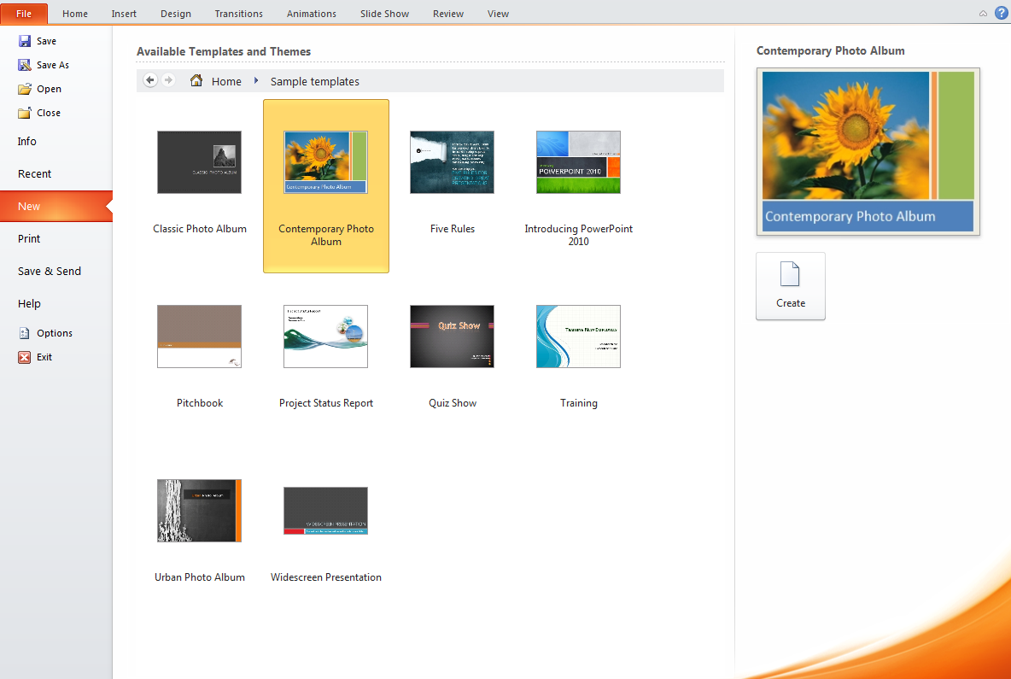

Microsoft PowerPoint Shortcuts

Apply subscript formatting | CTRL+EQUAL SIGN (=)
Apply superscript formatting | CTRL+PLUS SIGN (+)
Bold | CTRL+B
Capitalize | SHIFT+F3
Copy | CTRL+C
Delete a word | CTRL+BACKSPACE
Demote a paragraph | ALT+SHIFT+RIGHT ARROW
Find | CTRL+F
Insert a hyperlink | CTRL+K
Insert a new slide | CTRL+M
Italicize | CTRL+I
Make a duplicate of the current slide | CTRL+D
New presentation | CTRL+N
Open | CTRL+O
Open the Font dialog box | CTRL+T
Paste | CTRL+V
Print | CTRL+P
Promote a paragraph | ALT+SHIFT+LEFT ARROW
Repeat your last action | F4 or CTRL+Y
Save | CTRL+S
Select all | CTRL+A
Start a slide show | F5
Switch to the next pane (clockwise) | F6
Switch to the previous pane (counterclockwise) | SHIFT+F6
Undo | CTRL+Z
View guides | CTRL+G

Notes:

